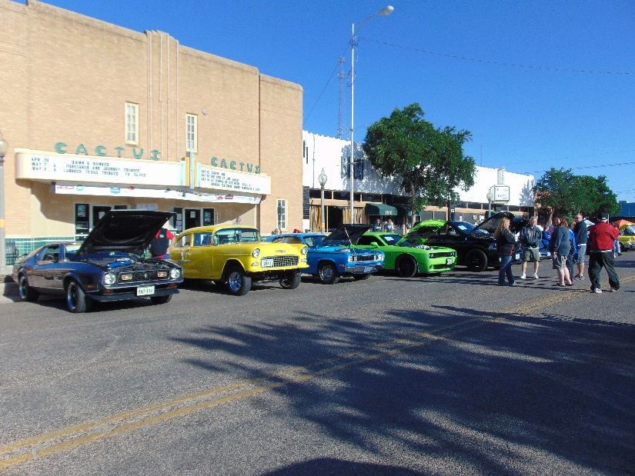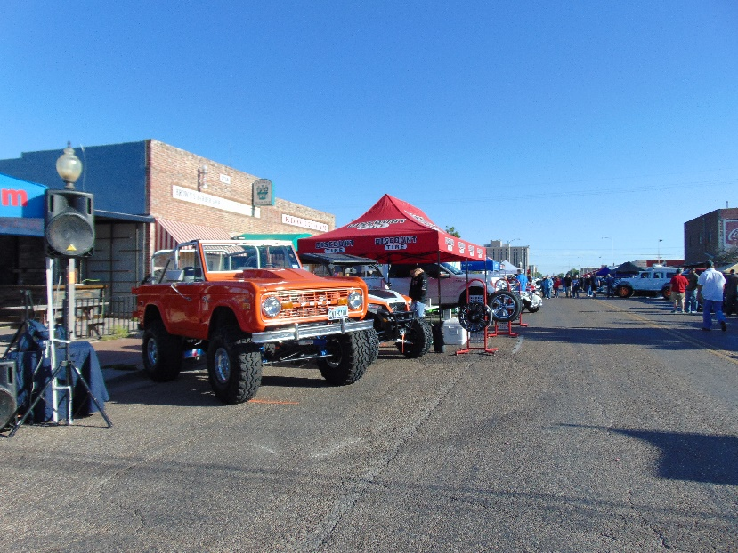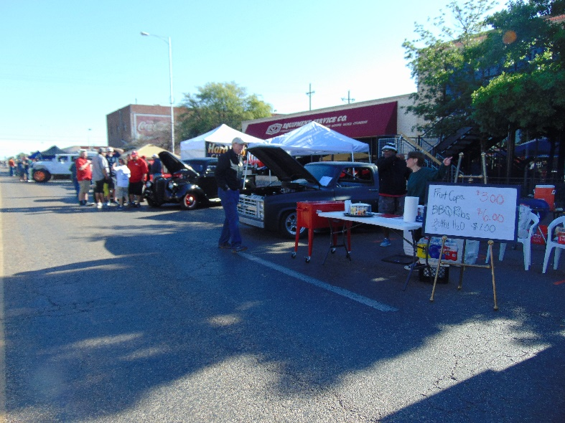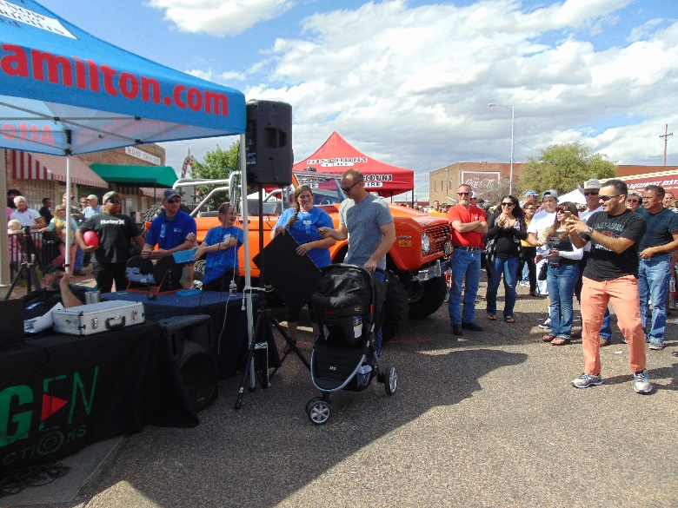
Blue Ribbon Rally
Event Description
April 25, 2020
The 22nd Annual Blue Ribbon Rally Classic Car Show is the signature fundraising event for Family Guidance & Outreach Center, a non-profit agency working to prevent child abuse and neglect. During 2019’s event, more than 9500 people came out.
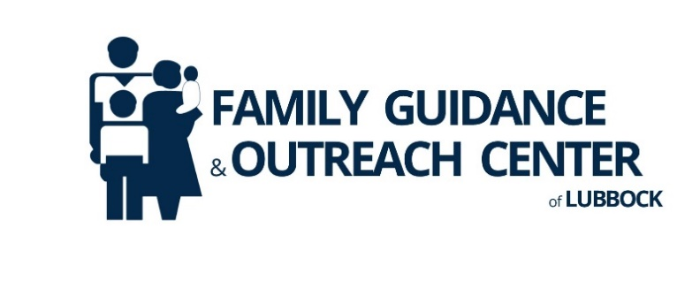
The event will be held in Lubbock’s Historic Depot Entertainment District on Saturday, April 25, 2020 from 10:00 a.m. – 2:00 p.m. The day’s events include a classic car show, complete with professional judges and awards, food and merchandise vendors and live music. The Blue Ribbon Rally is free and open to the public. For additional information, please visit www.lubbockfamily.org, or call (806)747-5577.

